**World Quant University**

**Professor: Ivan Blanco**

**Alpha Design I**

Nikolas Lippmann Pareschi - [nikolaslippmann@gmail.com](mailto:nikolaslippmann@gmail.com)

**Unit 6 - Assignment**

This assignment is aimed at getting you comfortable with WebSim and its usage.

1. Log onto your WebSim account and navigate to the Alpha Section
2. Write a simple Alpha Expression (example Rank(-Delta(close,3))) and simulate the expression under each of the following scenarios:
   1. Universe Choice – TOP3000, TOP1000
   2. Delay – 0,1
   3. Neutralization – None, Market
   4. Max Stock Weight- 0.1,0.5

This would lead to a total of 16 runs to cover all the combinations. A sample screenshot of running the Rank(-Delta(close,3)) Alpha Expression on USA/D1/TOP3000 Universe is provided in the attached PDF.

3. Compare and Contrast the Stats of each of these runs.  Which simulations worked best - give your views as to why.

4. Share the PNL and Sharpe ration of each of the graphs.

Alpha Expression:

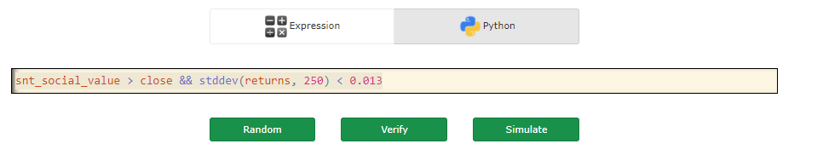Case 1:

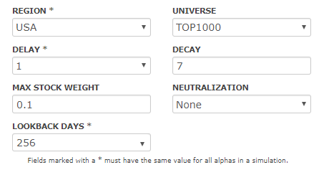

Results:

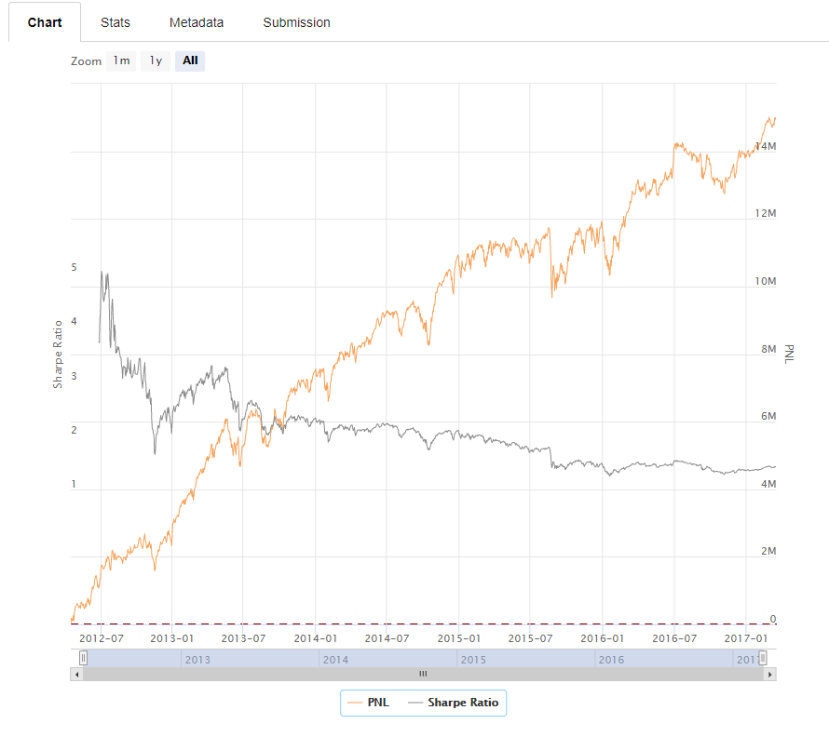

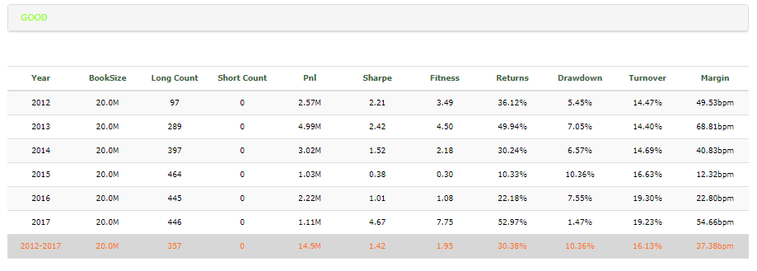

Case 2:

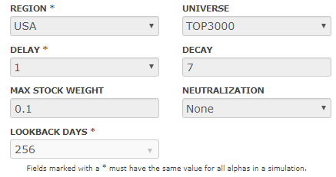

Results:

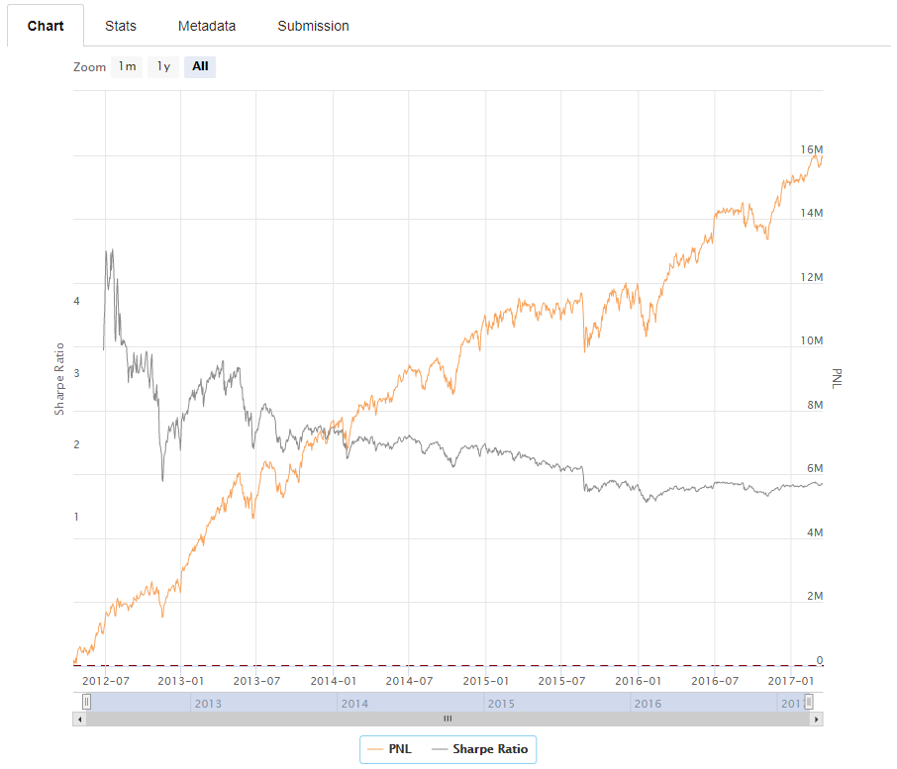

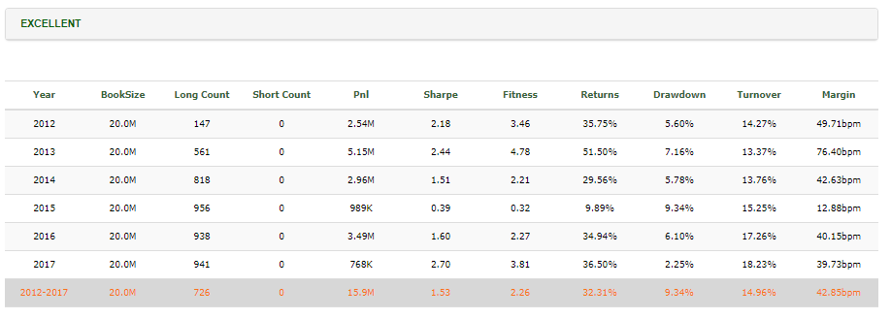

Case 3:

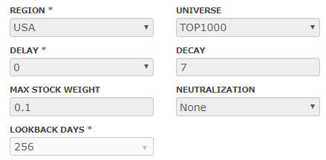

Results:

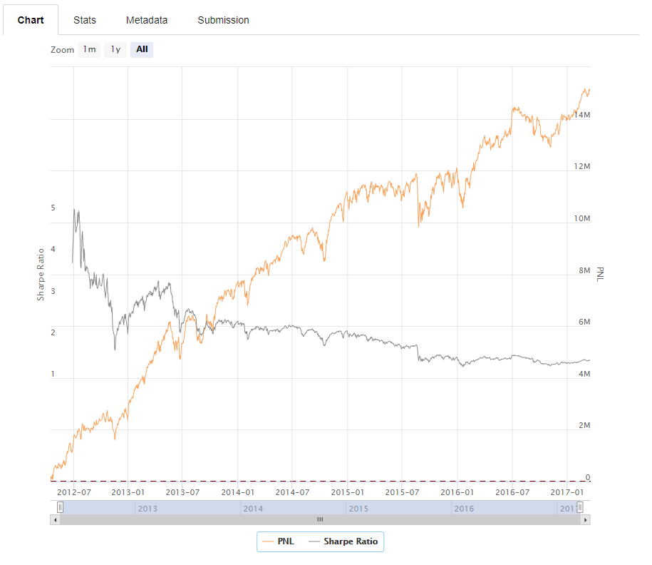

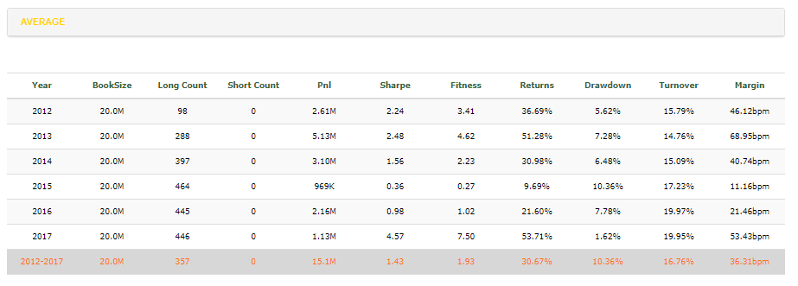

Case 4:

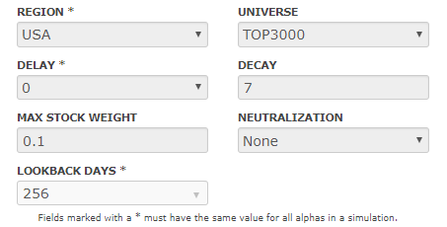

Results:

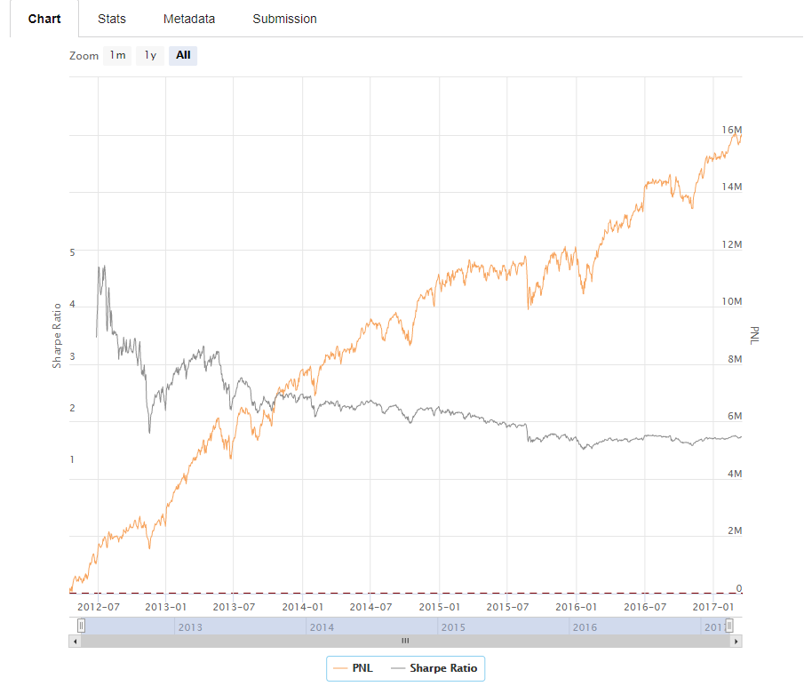

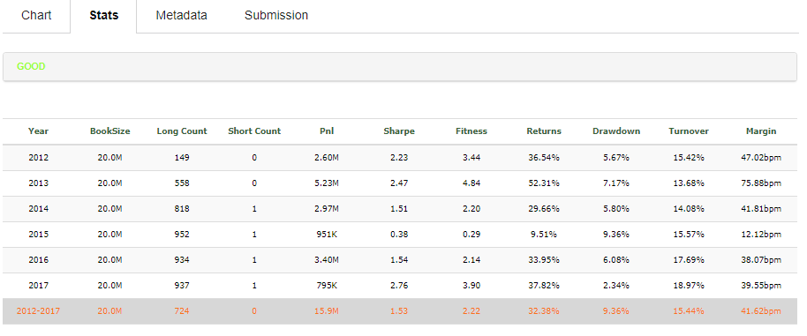

Case 5:

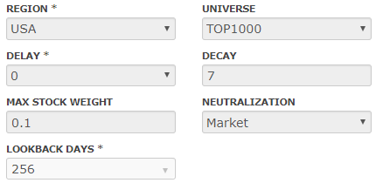

Results:

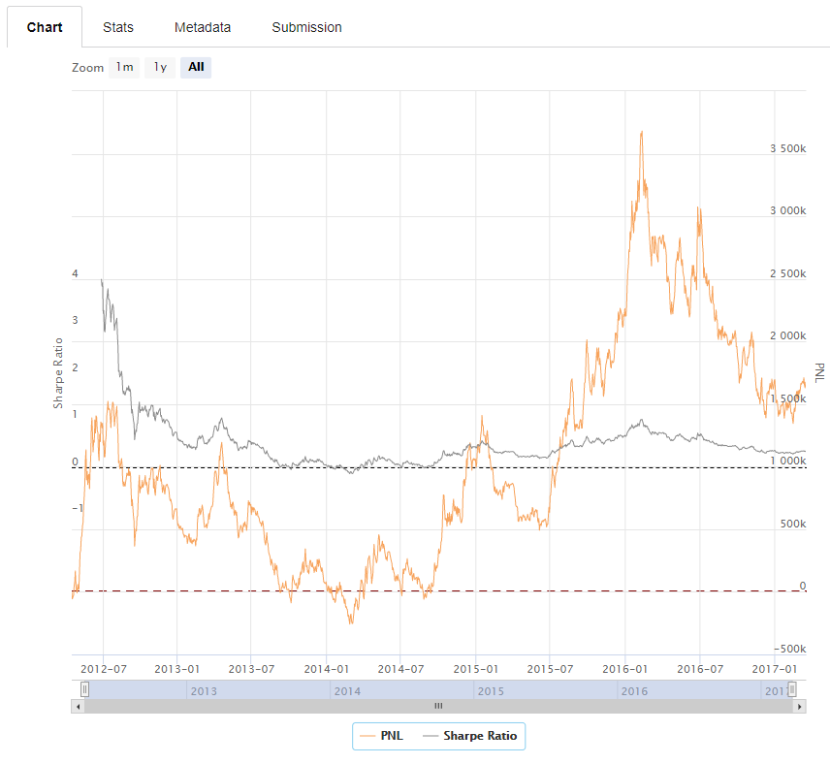

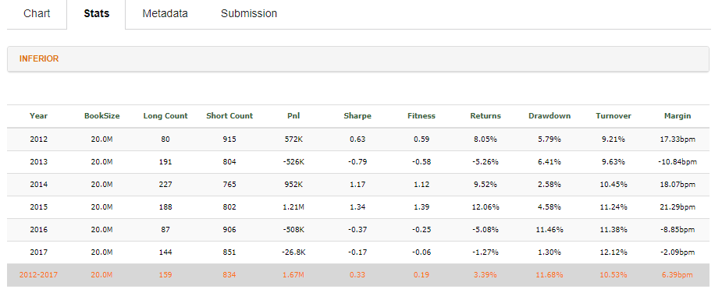

Case 6:

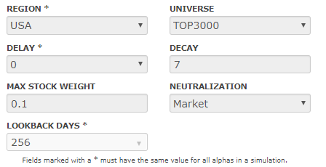

Results:

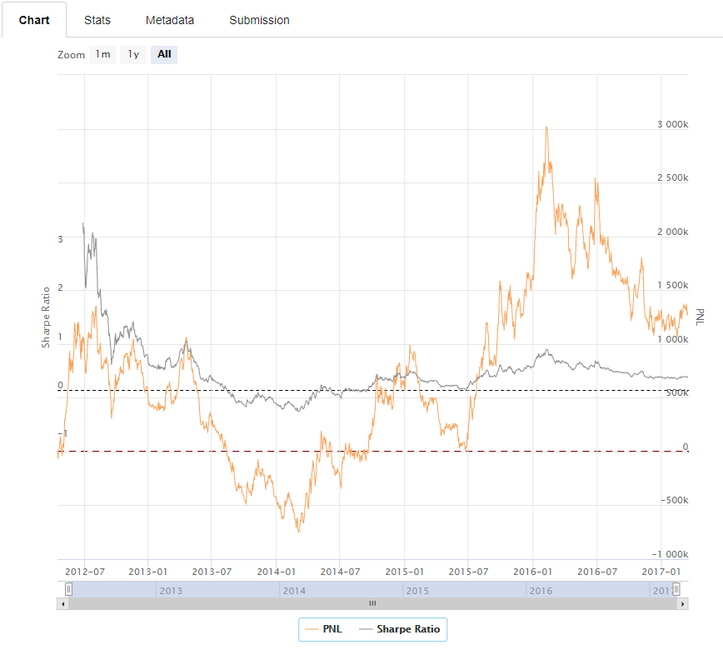

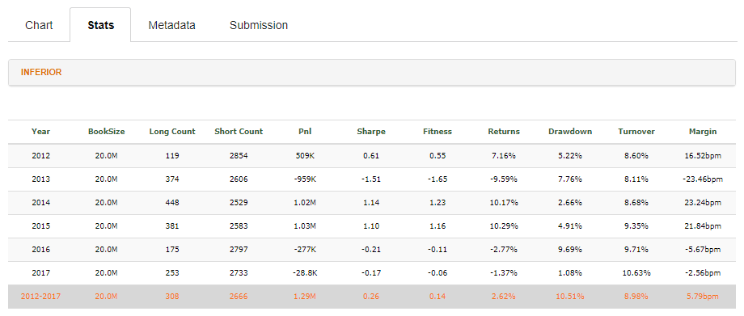

Case 7:

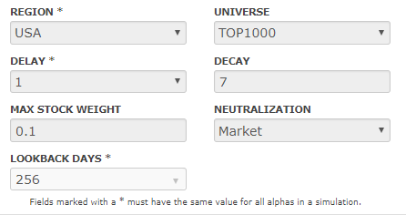

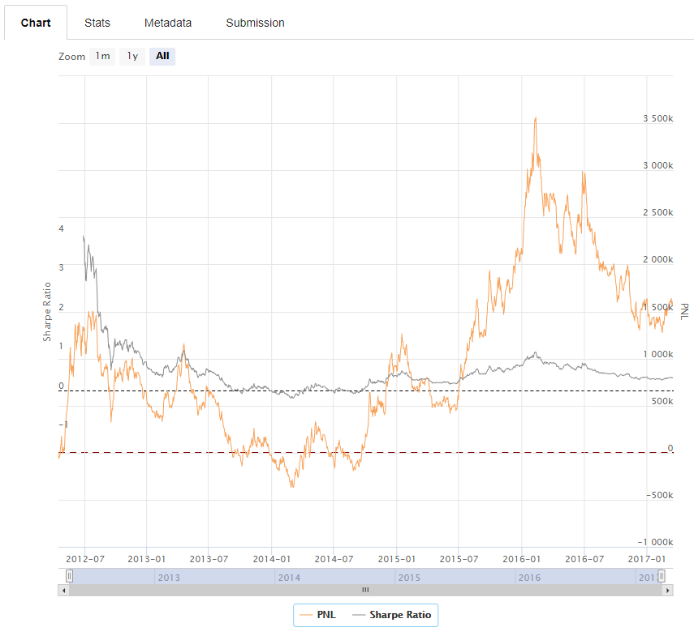

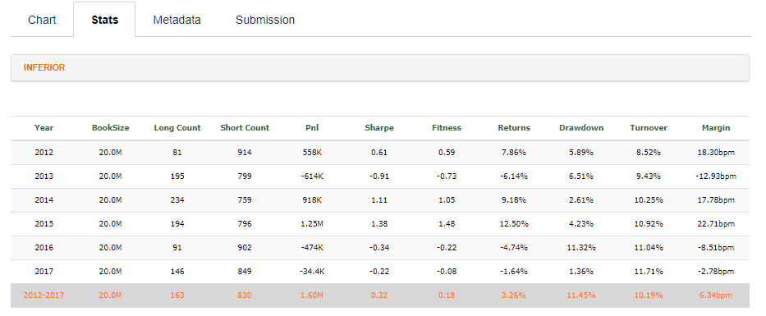

Case 8:

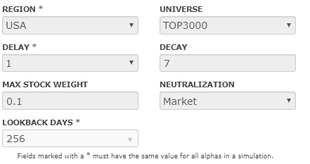

Results:

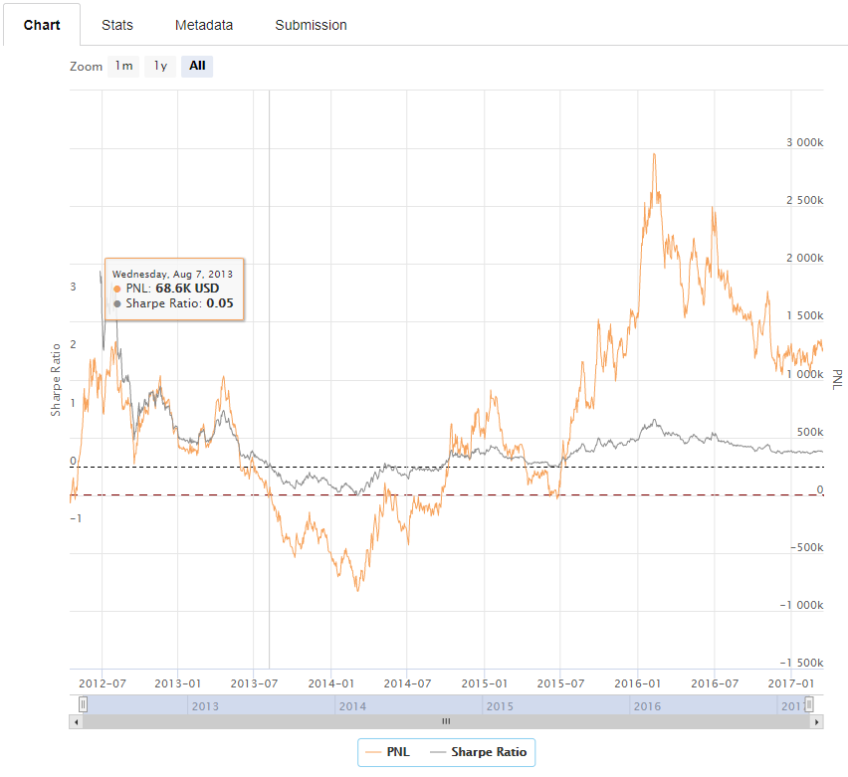

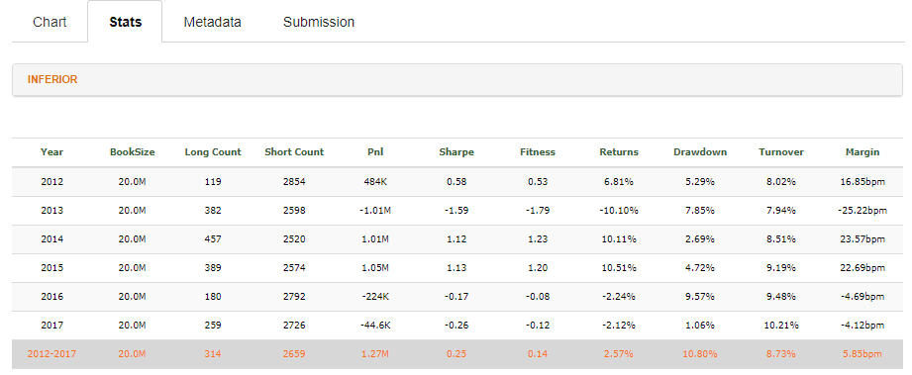

Case 9:

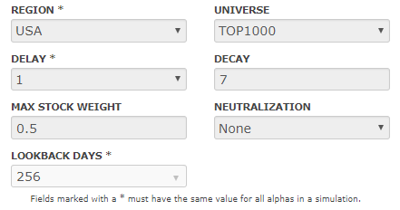

Results:

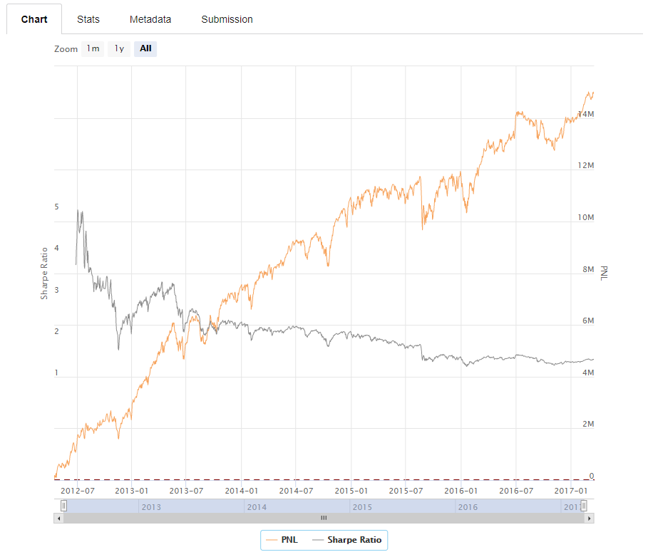

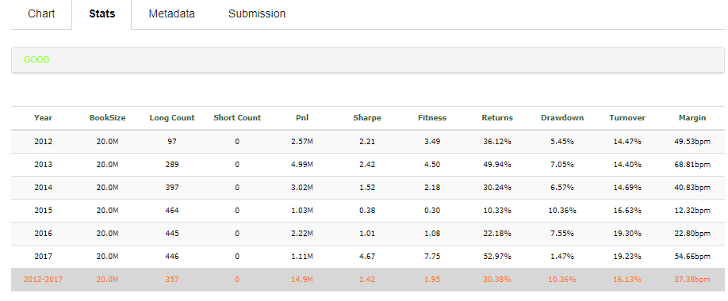

Case 10:

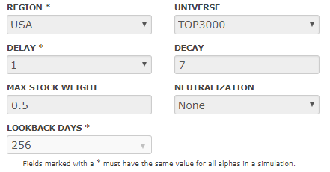

Results:

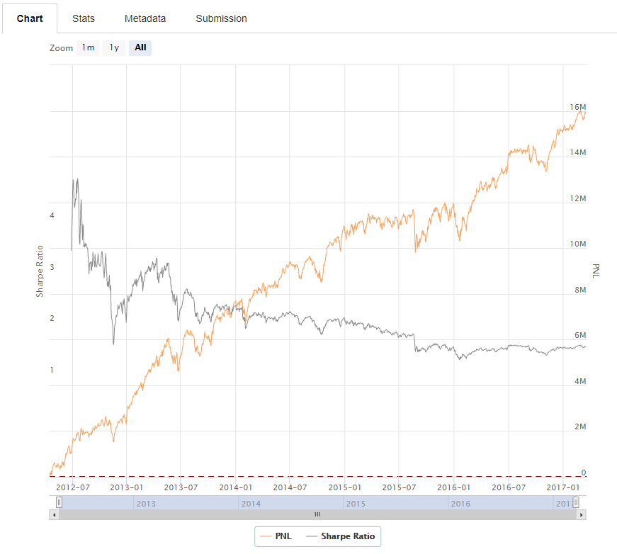

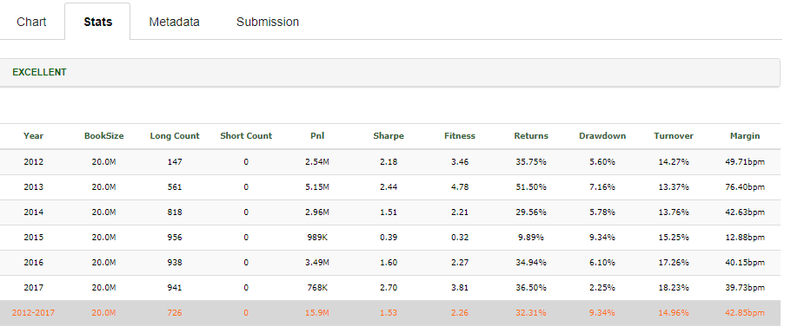

Case 11:

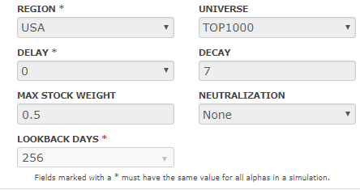

Results:

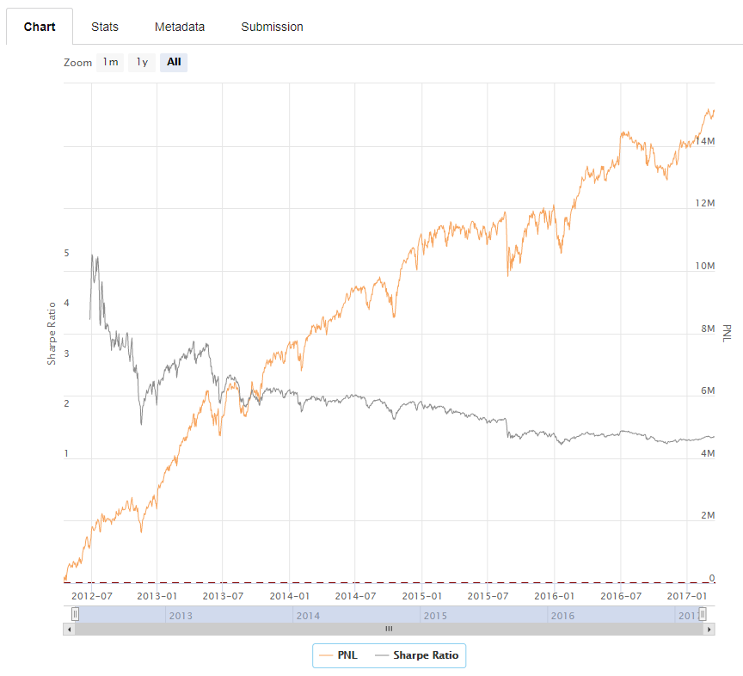

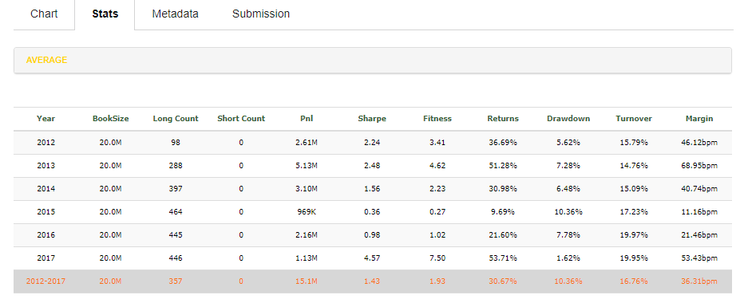

Case 12:

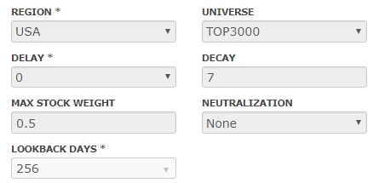

Results:

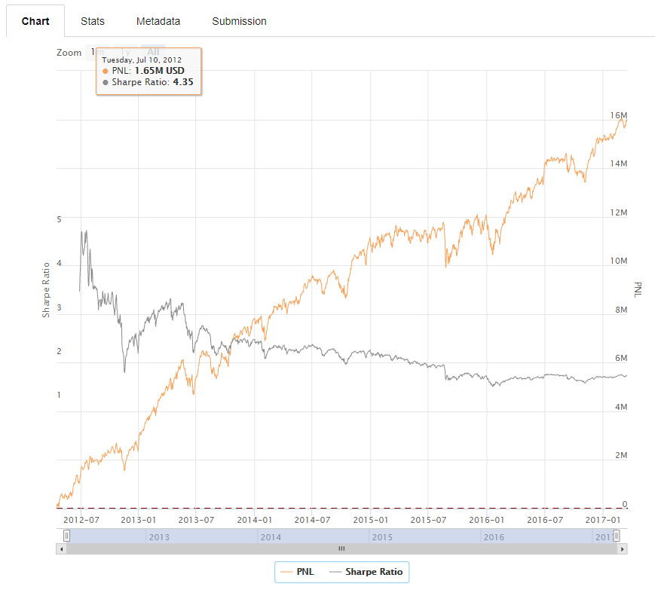

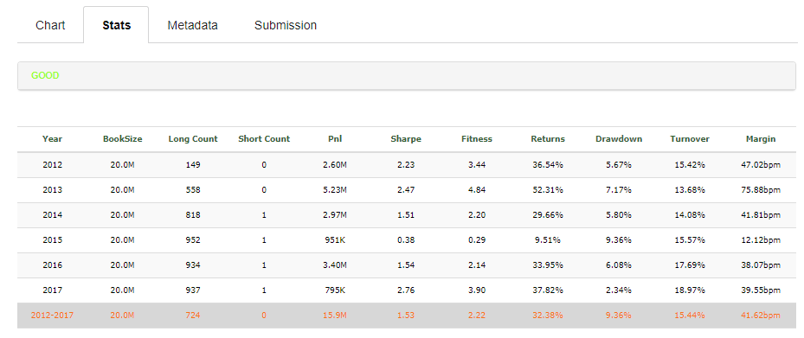

Case 13:

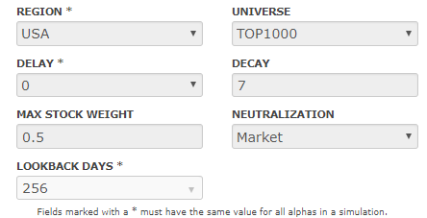

Results:

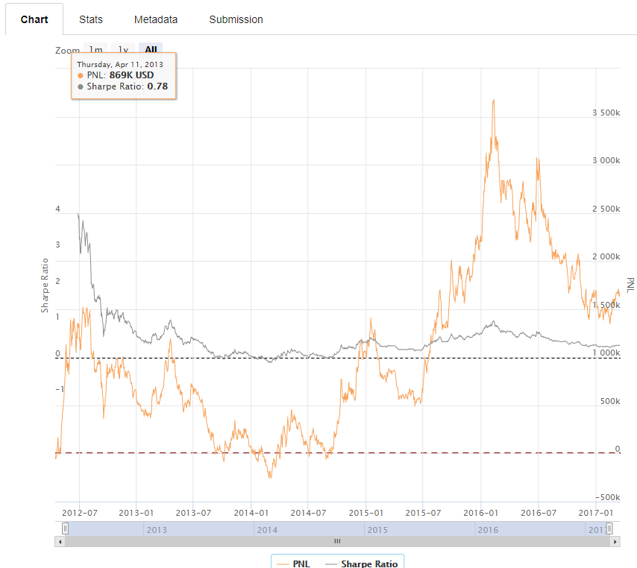

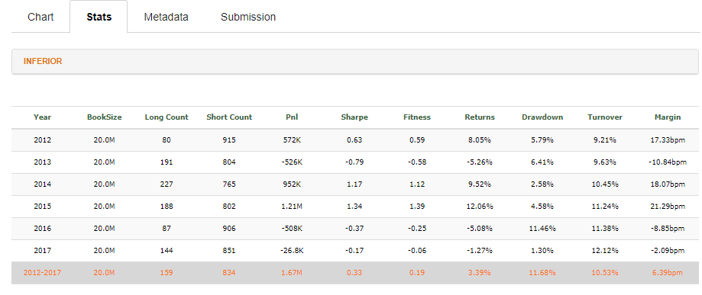

Case 14:

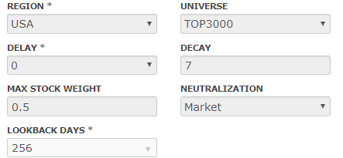

Results:

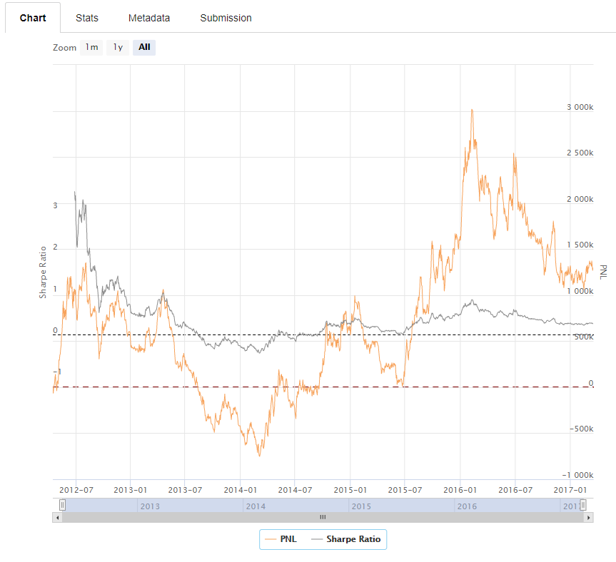

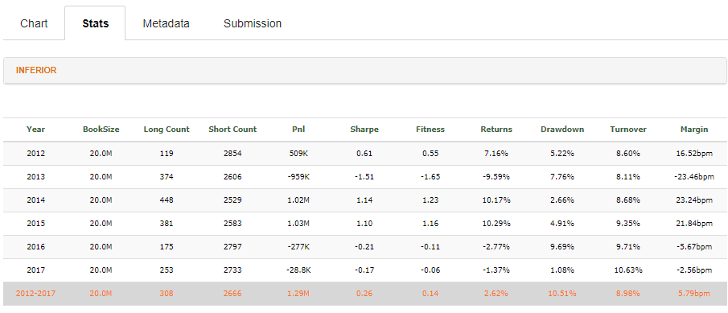

Case 15:

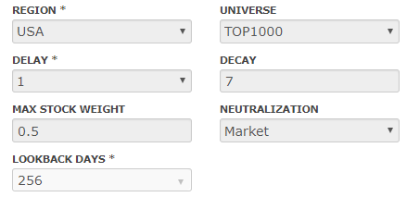

Results:

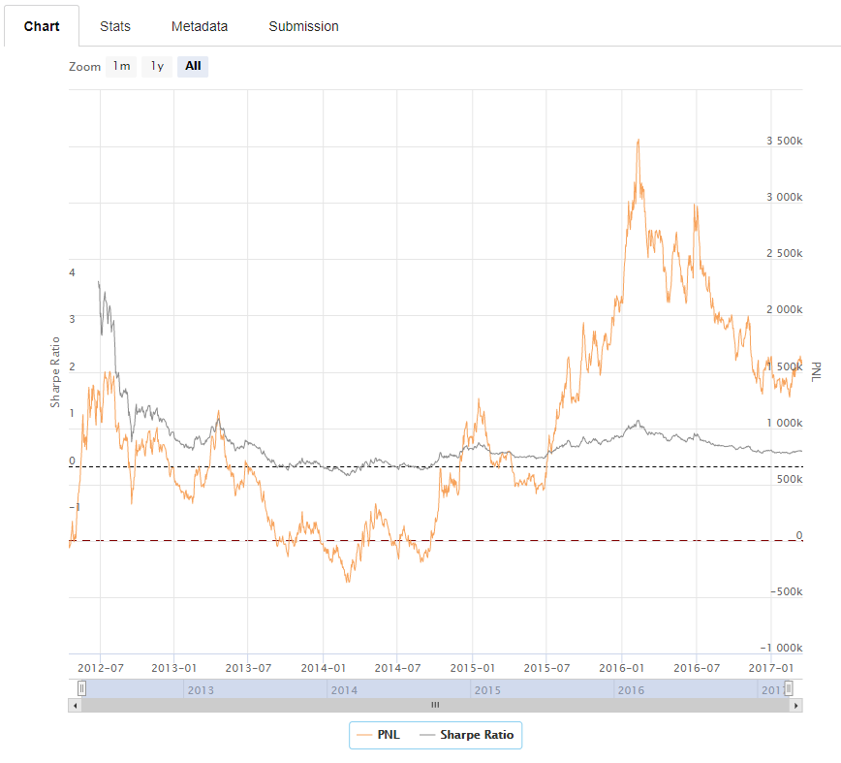

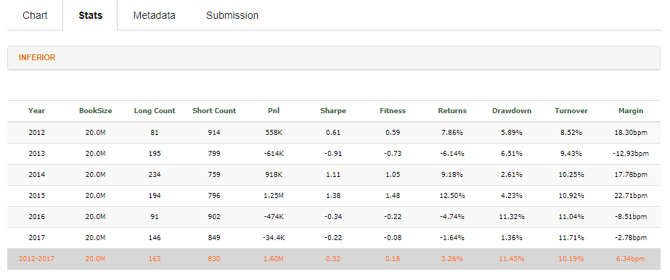

Case 16:

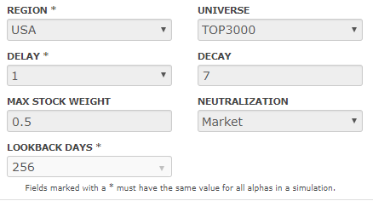

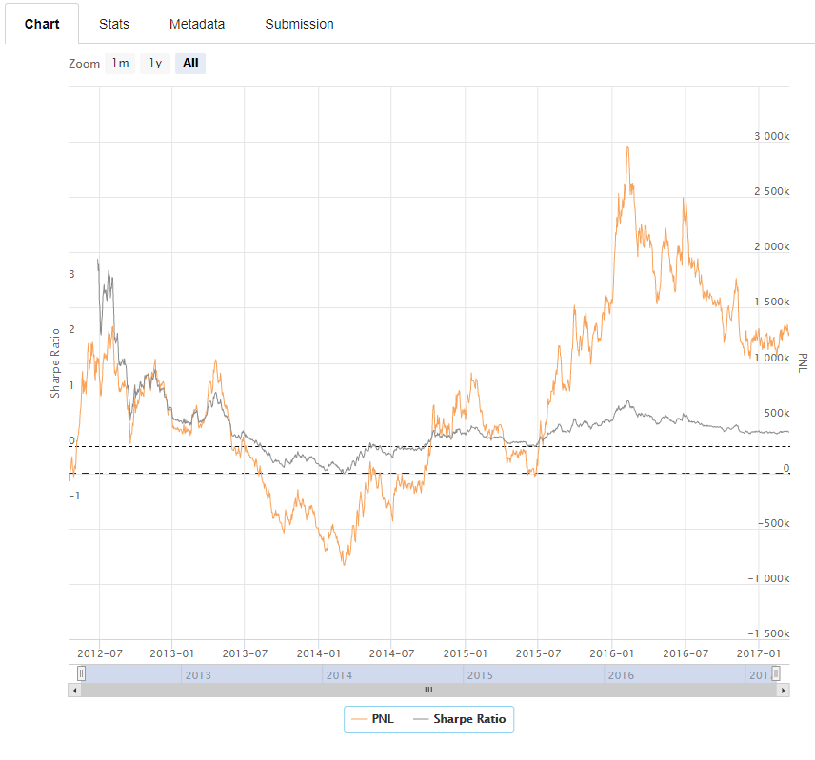

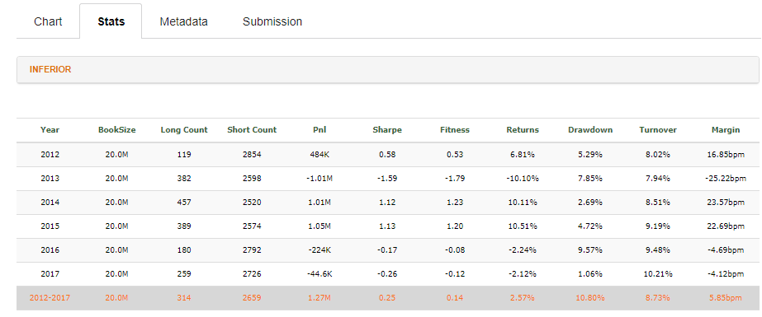

Conclusions:

As one can observe from cases 5, 6, 7, 8, 13, 14, 15, 16; if we change the *neutralization to Market* the stats are always inferior and we always have a sharp ratio below 1. *The neutralization as None* is much better as seen in 1, 2, 3, 4, 9, 10, 11, 12. I believe this happens because the edge of the strategy comes from being long in great stocks considering sentiment and low volatility. So the neutralization just messes up with the alpha of the strategy.

If we compare the pairs: 8-16, 7-15, 6-14, 5-13, 4-12, 3-11, 1-9, 2-10 we will notice that the variable *Max Stock Weight* has no effect at all. It is the same, 0.1 and 0.5. This happens because our strategy is very selective so we have always less stocks than the maximum allowed at the time the trades take place.

If we compare the pairs considering the *universe* we will notice the *top 3000 universe* was superior than the *top 1000 universe* in 75% of the cases: 1x2; 3x4; 7x8; 15x 16; 11 x 12, 9 x 10. In the cases: 13 x 14; 5x6 the top 1000 universe was superior, considering Pnl and Sharp ratio. It seems that our strategy works better in the small cap universe. This makes sense as usually they are less monitored by the large funds so it is possible that they really have more alpha.

If we compare the metric Delay we will notice that Delay 0 has a higher sharp ratio in pairs 1-3, 5-7 and 6x8. b 2-4 was a draw in PNL and sharp but Delay 0 wins if we take into account the drawdown (9,34% x 9,36%). But the classification of the strategies are always better in the Delay 1 cases. This happens because web sim gives preference to Delay 1 zero which are able to be executed with less slippage. The pairs above 9 until 16 are symmetrical because the Max Stock Weight effect has no effect at all.